Alex Mekovsky
COSC 320
Enyue Lu
4/12/2023
Lab Report 08
Lab Report: I was successfully able to complete all required parts of the lab. I finished implementing preqrec.h and I was able to build the main to perform the goals needed. Below is my output of the lab, matching the sample output’s ordering.
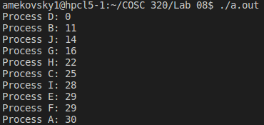

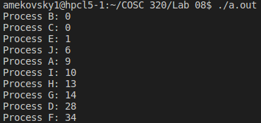

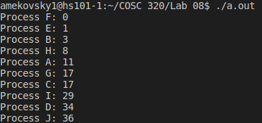

Overall the lab took me roughly three hours to successfully complete. My biggest issue was implementing the actual main file, as I was confused as to how the procReqQue was to be implemented in the code, and how miniPQ was supposed to be declared. After a little bit of reading, I was able to successfully implement both without trouble. My next biggest issue was printing out each priority queue value as intended. At first, it was printing largest priority to smallest priority, so I would get something like above but reversed. After a while of tinkering with the code, I was able to get it to print out the style intended by tinkering with the < overloading operator by switching the declaration from a < to a >, allowing me to print out the priority queue in the correct order.

